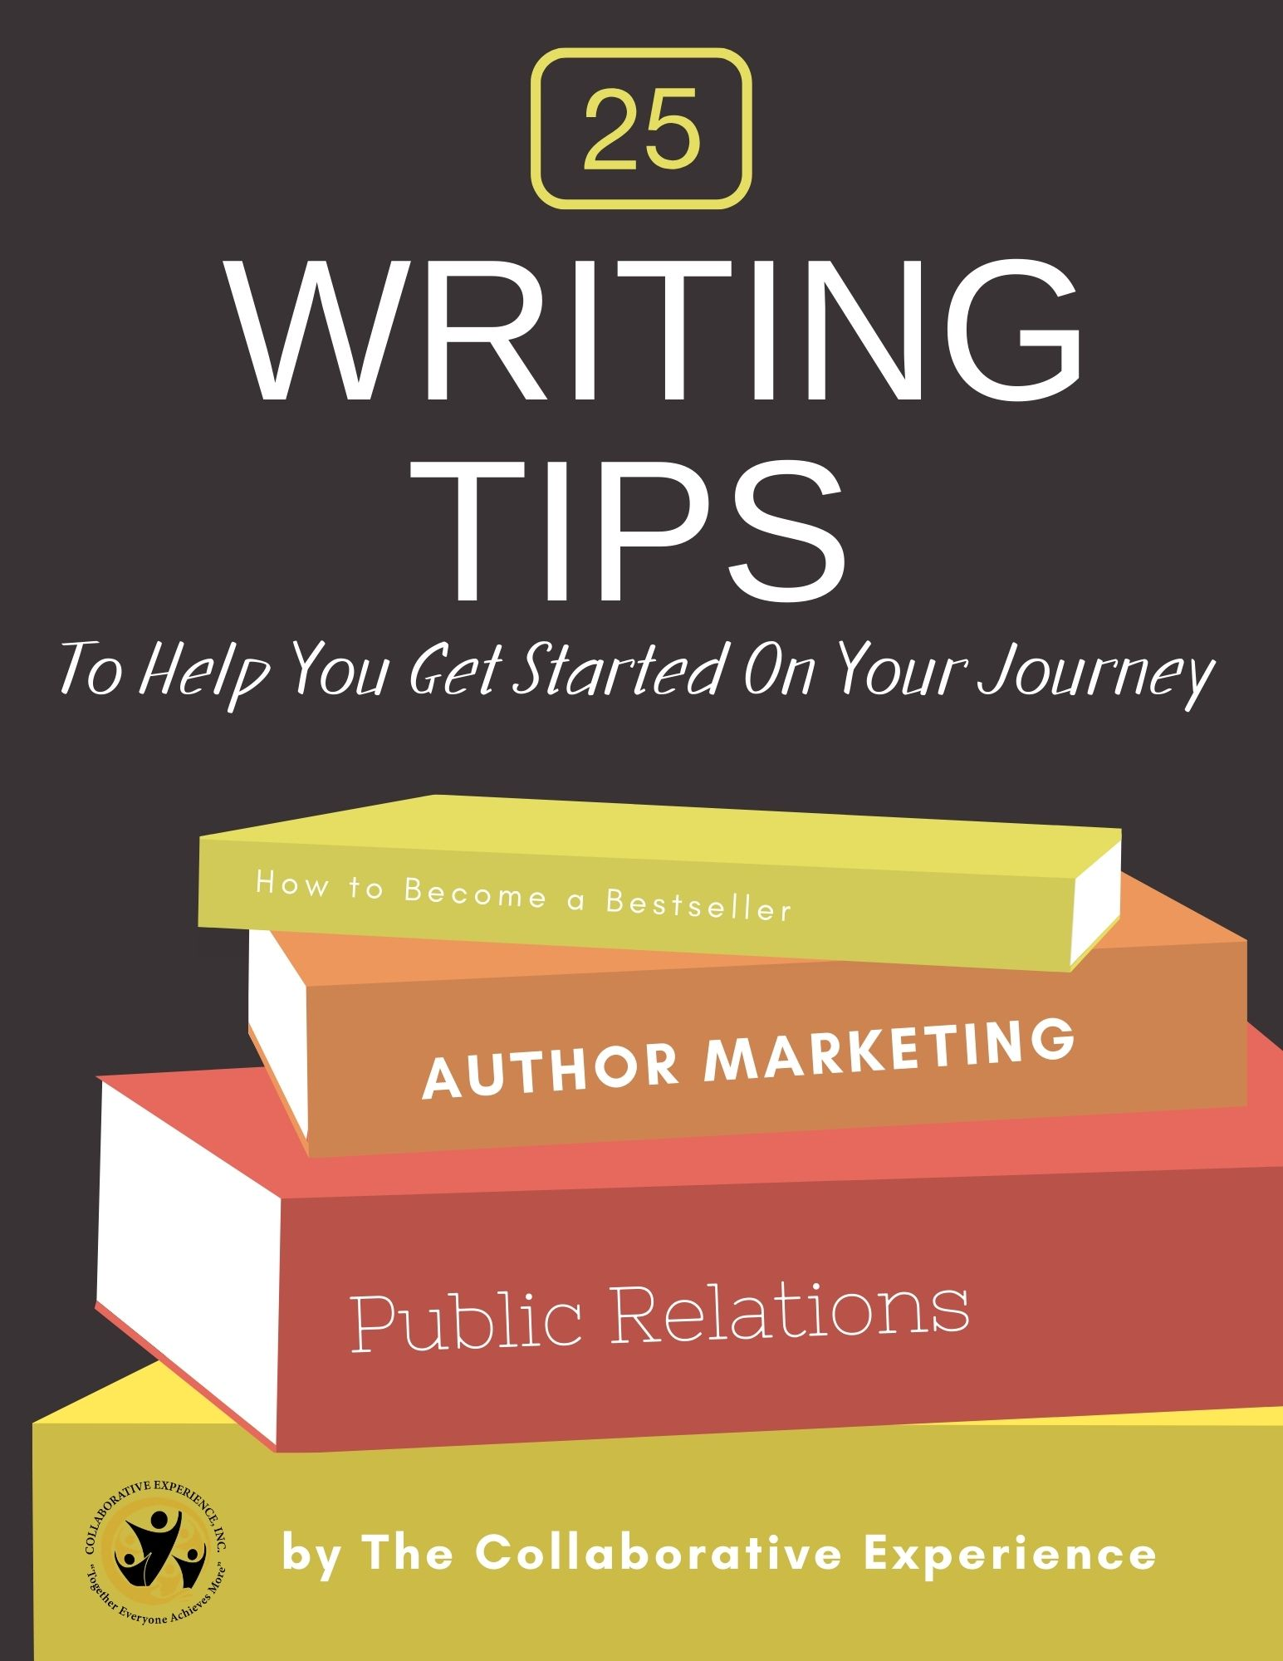

Writing Tips Made Easy

Introduction

If you run a blog or website you understand the need for writing regular content. While this may sound easy, it is not always easy to come up with ideas of what to write about. Even then you need to know how to write a compelling blog post that will attract attention.

When it comes to writing online there are a few differences which you must be aware of. Writing this type of content is different than writing a novel or non-fiction book.
Inside this ebook you will find a compilation of 25 writing tips which have been designed to help you become a better writer.

Just implement one writing tip per week to improve your style, writing techniques, creativity and the amount of content you create.

I am sure that you will enjoy using these tips and will have fun putting them into practice.

Start Writing on a Daily Basis

The more you write the better you will become at writing. So, it just makes sense that
you want to get into the habit of writing every day. You don’t have to start writing pages upon pages each day. Your goal is to form the habit where you sit down at your computer and start typing words into a document or notepad.

You can write about anything. For example, you may want to write about your activities the day before. Start mapping out a business plan or outline blog posts. Write about anything that gets you into the habit of actually writing. You may even want to practice writing short posts which you could then use as content for your social sites.
It may be difficult at first to write every day. Just remember, as with any habit, if you commit to doing this daily you will be writing regularly in less than one month.

Start Reading on a Daily Basis

The more you read the better you writing ability will be. Plus, by reading you will be keeping up to date on current affairs and topics. This will provide you with useful insights and topics that you can write about on your own blog.

It also helps to read a good variety of content and material. Don’t just limit yourself to reading a magazine or book. Get into the habit of reading newspapers, short stories, blog articles and more. Take the time to read up on a new hobby or skill that you have always wanted to learn.

By exposing your mind to a variety of content your vocabulary will expand. You will find that the task of writing becomes easier. Plus, you will find that you have more topics on which you can write about.

Write in a Comfortable Place

If you are seriously trying to write a long article or even start a book you need to have a comfortable place to work in. This will vary depending upon your personality. Some writers enjoy writing in a quiet room at home, others prefer to write outdoors when possible. Yet other writers find they get inspired and can write more when sitting at a local coffee shop or restaurant.

No matter where you choose to write, find a place that works for you. If you have small children or a busy schedule you may prefer to get up earlier and use that time for writing.

By placing yourself in a comfortable setting you will find that your words flow easily. If your body is not in a comfortable place then neither is your mind.

Write for Your Audience

When it comes to writing online content for the internet your biggest concern is that you will want to cut out all the fluff and padding of your work. While it is still important to pay attention to your use of grammar, spelling and punctuation your main concern is to keep your writing concise.

It is still important to develop a style so that your audience can identify with you. You will want to aim your writing at a general level. This means not using overly long or difficult words and talking to your reader as though you were writing to a friend.
With the emergence of the internet writing styles are definitely more relaxed than ever before. It is still important to maintain a professional quality of your work so that you can brand yourself as an expert in your niche.

Use Complete Sentences

While writing for the internet requires you to be friendlier, you still need to write correct sentences. Your sentence structure should be complete and concise. An example of an incomplete sentence is when you suddenly place the word ‘when’ at the beginning. The use of this word makes a statement incomplete such as in the following example:

When I complete this project. Instead you should write:
I completed this project.

If you use an online spelling and grammar checker an incomplete sentence will be referred to as a fragmented sentence.

Because online writing rules are viewed as more relaxed it is okay to break the rules now and again. You will notice that a lot of online content will have sentences that start with the words ‘and because’. This was definitely something that any good English teacher would tell you is not correct. But now it is viewed as acceptable.

Research Your Topic

Before you sit down and write you want to take the time to research your topic. This is extremely important with web based content. Always keep in mind that internet users are looking for current information and facts.

By researching first, you will have timely facts and information that you automatically include in your blog posts and articles. By taking the time to research, your content is more likely to be shown as relevant content in the search engines. What this means is that your posts, pages and articles are more likely to show up in the top results in any search engine.

Once you have compiled your research you will be able to easily create a good outline for your topic. You may even find that the direction you first had in mind has changed. Researching can help you discover new and unique angles that you had not thought of.

Use Current Events for Blog Posts

If you want to consistently create good content for your niche then it is imperative that you stay up to date with what is happening in your niche. This can be done by subscribing to other blogs in your niche by using an RSS Reader. Then simply get into the habit of checking your reader each morning for important news.

This has a dual purpose for you as a writer. Firstly, you will be staying on top of all of the latest news developments and gossip in your industry. Secondly this ‘news’ can easily provide you with a list of ongoing topics for you to write about.

Other ways to stay on top of news is by creating Google Alerts and by checking sites such as Google News regularly. Don’t forget to subscribe to top blogs in your field as they can help inspire topic ideas.

Create an Outline
If you find that you often get stuck writing a complete blog post or article have you considered using an outline? This technique allows you to simply fill in the outline, once created, in a step by step process. Once filled in your basic article is completed. Using an outline simplifies the writing process and makes it easy for you to create quick and informative posts.

A good outline includes:

- Introduction
- Body
- Conclusion

In the introduction you will basically tell the reader what they are going to learn by reading your article or post. In the body of your article make a list of the points or sub topics that you want to discuss. These points will become the sub headings of your article. After you have outlined your points you go back and write a couple of sentences on each one. This becomes the body of your article.

Once you get to the conclusion you simply wrap up and summarize the main points again. Then add a call to action for your reader and your new post is ready for publication.

Use a Mind Mapping Tool

If you liked the idea of using an outline then you are going to love using mind mapping tools for writing. A mind mapping tool is great for outlining individual posts and articles as well as for creating a blogging schedule.

You can use this tool to plan out content for months at a time. Come up with main topics and then add sub topics to your list. As well as listing sub topics you can list research sources and jot down ideas.

When you go back into your mind map you can add additional notes and thoughts. Before you know it, you will have basic content outlined for several blog posts at a time.

A great feature of mind mapping software is the ability to add colored nodes so you can easily identify topics, research and specific outlines.

Write in Short Spurts

Use a kitchen timer or download an online timer to your desktop and then use it. Most writers will agree that it is better to write in short spurts, rather than sit down for hours at one time.

There are several benefits of writing in short spurts including not cramping up your fingers and wrists from over typing, and not feeling overwhelmed or frustrated when your words do not flow.

Quite often taking a break frees up your mind and relaxes your body. When you sit down again to resume writing you will feel refreshed and ready to take action. You should notice that your writing flows easily and that you actually feel more creative. Experiment with how often to take breaks and see what works for you. Most people tend to find that taking a 10-minute break once every hour is extremely effective.

Develop Compelling Headlines & Titles

With any type of writing which is going to be published online you want to take the time to come up with compelling headlines. A good headline will attract your website visitor’s attention immediately, and this will entice them to read the entire article.
When writing your headline or title do not use all capital letters in it and avoid using punctuation. If you place a full stop or period at the end of your headline it will make the reader want to stop reading. By eliminating this punctuation your reader is more likely to continue reading your full article.

Examples of great titles are:

- Titles that ask questions or provoke opinions
- How to titles
- Step by Step titles
- Titles which stir feelings in your reader

When writing content, for online purposes, you want to try and include keywords in your titles. This will help boost your content within the search engines. Place yourself in your reader’s shoes and think of how you would search for this particular information. Then try to include these terms into your titles, headlines and sub titles.

Short Sentences Work Best for Online Content

When writing online content, you want to avoid long sentences. It is much better to write your content in short and concise sentences. This way you can offer your readers easy to understand information which is well thought out.

In addition, keep your paragraphs fairly short. It is important to understand that when someone is reading an article, post or website content online, they often scan the content first. This is why it is important to make use of sub titles and formatting techniques such as lists and bullet points. These things will catch the readers eye, pulling them in, and making them want to read more.

Practice writing short sentences with no added fluff. If you find that your sentences are extremely long, work on adding commas into the sentence structure. Then read your sentence aloud. If your sentence still sounds and feels long winded then try splitting into two shorter sentences.

Use a Friendly Tone of Voice When Writing on Your Blog

Conversational and friendly tones work best when writing online content. Use a passive voice in your writing. An example of this is:

The graphic designer was hired by our company. Instead use:
We hired the graphic designer.

When writing for your blog write as though you are chatting with your best friend or family member, someone that you know well. When you write in this manner your content becomes friendlier and adds that human touch.

A common problem with the internet is that a website often blocks the human element. Sometimes a reader doesn’t really know who has written the content and this adds distance.

By writing in a friendly manner you are forming a relationship with your reader and they in turn will learn to know, like and trust you more. This is extremely important for connecting long term readership for your blog.

Write to Attract Attention

This follows on from our last writing tip which covered writing in a friendly manner. With online content it is important to understand that your website visitor is looking for something. This could be the answer to a particular question or information on a particular subject. In essence they are looking for a solution to a problem.
You need to provide them with the solution and this solution must be evident quickly. Most website visitors will scan your page and if they don’t find what they are looking for, will leave in under 10 seconds.

This is why it is important to attract their attention immediately. This can be done by creating compelling headlines, using sub heading and lists. If the visitor thinks you may have the answer they are more likely to stick around and read the rest of your content.

Include Lists and Step by Step Tutorials

When creating content, you can make your content easier to read and more attractive by making use of lists and step by step tutorials. This offers several benefits including making your content more appealing to visitors. Instead of being faced with a long article they immediately see that your content is short and easy to read.

You can list main points and use bullet points or numbers to make them stand out on your page. As we mentioned earlier readers on the internet are in the habit of scanning content rather than reading every word in detail. So, using short points can help them identify if your content is what they are looking for.

Creating how to and step by step tutorials you are offering your readers a different type of content. If your article is dealing with how to learn something new then consider writing out in point or step form.

Structure Your Content

Structuring your content includes taking the time to think about the topic that you are writing about. You don’t want to go rambling on about nothing in particular. Instead come up with a specific idea or subject and discuss that on your blog.
By talking about one thing at a time you will have the ability to write clear and concise articles. These will be informative posts that will engage your readers in a friendly manner.

To do this effectively you should get into the habit of writing out the main points of your article. Then go back and start explaining or discussing each one in a single paragraph.
By the time you have filled in all of this information all that is left is your closing paragraph.

The last paragraph is normally a quick recap of what the reader has just learned. Plus it should include a call to action. This could be sign up to a newsletter or to receive a free gift or it could be to purchase a recommended product.

Use Clear Language

One of the biggest mistakes you can make when it comes to writing online content is to use fancy language. This can be a foreign concept to many writers, but believe me your readers will appreciate clear and easy to understand language.

Only use technical terminology when required. If you are writing a white paper for university graduates then you will, of course, use different language as compared to writing for young adults.

As well as not using fancy or technical jargon you don’t want to add fluff to your content. While adding descriptiveness to stories and fiction is good, it is not always appropriate for shorter pieces of content.

If you are in the habit of writing colorful content, try going back and removing unnecessary words and expressions. Make a point of keeping each sentence clear and to the point. If you stray off topic simply remove the section.

Use Summaries

A summary is basically a quick recap of what your article or post is about. You are actually telling the reader what you have just told them! A good summary consists of one good paragraph and this summary can be used to describe your article as well.
Learning how to write a good summary is important if you want to submit articles to article directories for example.

As you gain experience with crafting summaries you will also be improving your copywriting skills. So, when it is time to write a sales page you will have an easier time of coming up with shorter sentences to reflect benefits and key points.

If you condense your summary even further, into 150 characters, this becomes the sentence that is displayed by the search engines when your website shows up on the results page.

Include Images and Graphics

There is one major difference to writing online content and that is the use of images, graphics and photographs. Images can really help make your content visually appealing and entices the reader to actually stay on your site and read your content.

When using images try to use images that relate to what your article is about. Plus, with the increased popularity of social media sites, people love sharing images. This can help get your content more views and website traffic. Try to use images that people can ‘pin’ to sites like Pinterest.

Images and photographs help to break up long articles and make them appear shorter and easier to read. It is very easy to insert images into a document, just

use the insert feature in Word. Plus, you can then use the Picture tools to add a border, color or special effects to your images.

Remember an image help draw the reader’s eye to the page and compels them to continue reading. If you aren’t in the habit of adding images try using some in your next article.

Make Use of White Space

When you write content that you wish to post on your website it is important to take
the visual appearance of the piece into consideration. You don’t want to publish a long article that is all text and very little else. Immediately visitors view this as ‘boring’, and they will click away without bothering to read it.

While you can still publish long articles, you can make them look less ‘boring’ by breaking the piece up into smaller sections.

One way to do this is to write smaller paragraphs. When you have more paragraphs, whiter space appears on your site. This has the effect of making your article look smaller and easier to read.

Including headings and sub titles also goes a long way in helping to break up your content. The more manageable your content appears, the more readers you will attract. If your article is extremely long you may want to consider breaking into 2 or 3 smaller posts and then link to each one at the end of the article.

Include a Call to Action

When writing articles that are to be published online you normally want the reader to perform some type of action after reading it. This action is referred to as a Call to Action. It can include having your reader click on a buy button, liking or sharing your post or giving up their email address in exchange for a gift.

If you don’t tell your reader what you want them to do at the end of your article they will simply click away. Instead it is important to lead your reader somewhere.

To achieve this, you want to make your call to action very clear. If you want them to sign up for your newsletter, tell them how to do it. If the required action is to click a link put the link there for them to click on!

By including a call to action your conversion rates will increase as will your profit margin. Don’t expect people to know what action you want them to take, instead show them!

Write, Read, Edit, Proofread and then Repeat

Get into the habit of writing your content and then letting it sit at least overnight. This way when you open it up again to reread and edit it you can pick up on errors easily. Do not simply write and publish your content without proof reading it.

While many programs such as Word and Open Office do come with built in spell checking systems, these are not always that accurate. Instead you want to get into the habit of editing and proof reading, then rewriting if necessary before going back and proof reading again.

When editing and proof reading your work do so with an open mind and pay attention to the small details. It can be so easy to overlook words by reading too fast. Instead read slowly and carefully. If you find yourself faltering over a sentence and have to read it more than once, stop and fix the sentence.

Don’t be Scared to Cut & Rewrite

By letting your content sit before it is published you can reread it with fresh eyes. If you are not totally happy with it take the time to cut out sections and do re- writes if needed.

Remember whatever you publish online becomes associated with you. If you are trying to brand yourself and your business, then publishing informative and thought-provoking content is vital.

You should feel proud of any piece of content which you create. Try asking yourself if this is something that you would want to read, it should be!

At this stage in the game you want to watch for certain words that you repeat often. When this happens try to look for alternative word choices that can help liven up your work. One easy way to do this is by using the synonym and thesaurus features in programs such as Microsoft Word. This is a really way to change your work without having to do major rewrites or cuts.

Voice Your Opinions

Don’t be worried about voicing your opinions when you write. Of course, you may not want to become too controversial on certain topics. But there is nothing wrong with voicing your thoughts and opinions on any subject.

By doing this you could easily create content that becomes a little controversial. This type of content is enjoyed by many people, especially on social sites. They love to add their own opinion before sharing with their friends. You content could easily go viral and receive thousands of views.

By voicing your opinions, you are opening the floor to allowing your readers to add their own thoughts and comments. This can be a fantastic thing, and can help you receive hundreds of extra readers to your blog. Many super blog conversations have been conducted in the comments section.

Keep a Notepad for Ideas

It can be extremely helpful to always carry a notepad or book of some kind with you. This way if you suddenly come up with great ideas for a story, blog post, article, report or book you can scribble away to your heart’s content.

Notepads are great for using to brain storm ideas and thoughts. They are perfect for using at any time and you can even revert to a good old-fashioned notepad and paper. How many times have you suddenly come up with great ideas and had nowhere to write them down? By the time you reach home or sit at your computer your ideas are long gone.

You can use any type of notepad for this and several online notes can be synched across all of your devices these days. Evernote is one good example of this.

Thank you for downloading this guide. We would be happy to assist you with your writing and book publishing needs. Please feel free to contact us at

Phone: 917-501-6780 (Julia D. Shaw)
Phone: 646-421-0830 (Toni Coleman Brown)
Email: collaborativeexperience@gmail.com
Website: www.thecollaborativeexperience.com

